**HandsOn 2**

1. Create Repo & then click on Add logic app. Select rss template after the black template selection.

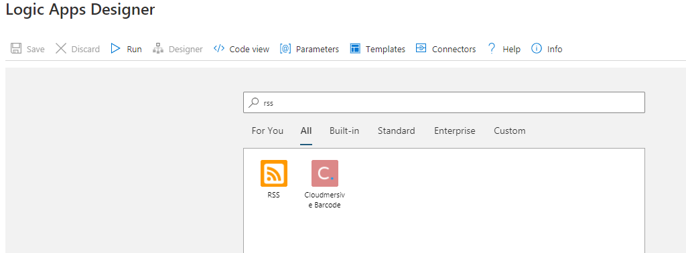

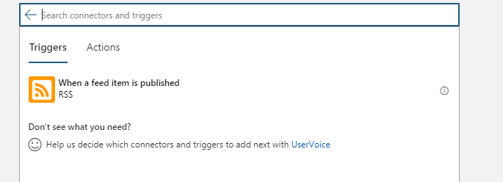

1. Give the url of Times of India & select the frequency.

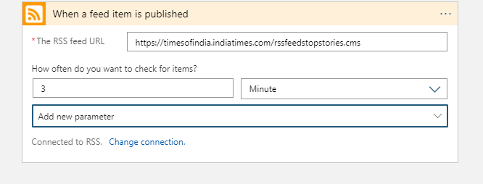

1. Add new step and add the gmail as an action.

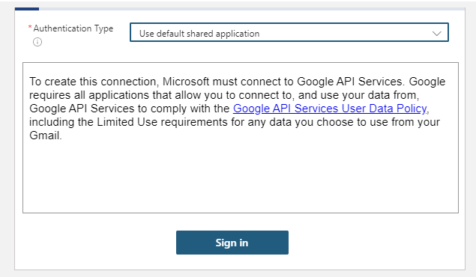

1. Select the attribute from the dynamic tabs.

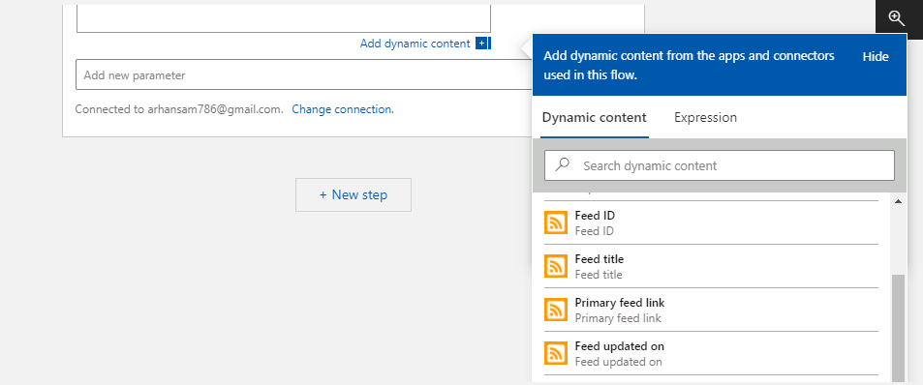

1. Save it and you will receive the mail whenever there is an update

